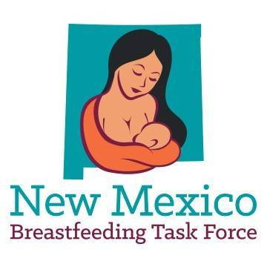

FOR IMMEDIATE RELEASE

July 31, 2020
Contact: Monica Esparza, Deputy Director
505-395-6455 or monica@breastfeedingnm.org

The New Mexico Breastfeeding Task Force Celebrates World Breastfeeding Month by Building Community Virtually

Albuquerque, NM – Tomorrow, August 1st, marks the start of World Breastfeeding Week – a global campaign to raise awareness and galvanize action on themes related to breastfeeding. This year’s theme is Breastfeeding for a Healthier Planet, focusing on the impact of infant feeding on the environment/climate change and the imperative to protect, promote and support breastfeeding for the health of the planet and its people.

The New Mexico Breastfeeding Task Force (NMBTF) observes the full month of August as World Breastfeeding Month and is hosting multiple events throughout August to honor our communities, create awareness, and to continue building environments where breastfeeding is the cultural norm. Because of concerns with COVID-19, this year’s events – which are typically held in-person – are being held virtually. NMBTF’s local chapters, located all over New Mexico, will also be hosting various events this month.

“We are working together to create a world without barriers to breastfeeding,” said Monica Esparza, Deputy Director of the New Mexico Breastfeeding Task Force. “The virtual events that we are hosting are a testament to our agility as an organization, and to our commitment to honoring all types of families. Although we typically spend this month celebrating in person, we know that the best way we can support our communities right now is by promoting health and safety, encouraging dialogue and participation, and exploring ways that we can care for the world we live in,” she said.

All of the following events can be accessed on NMBTF’s website at breastfeedingnm.org/WBM. All families, healthcare professionals, and community members who want to support parents and babies are welcome to join. The upcoming events are

- Global Big Latch On & lactation themed Loteria – Saturday, August 1st at 10:00 am
- Feeding through Generations: A Virtual Cooking Show – Saturday, August 15th at 11:00 am
- Virtual Picture Wall: Feeding Through Generations
- Virtual Breastfeeding Art Gallery
- Virtual Website Scavenger Hunt

For more than 25 years, NMBTF has worked to create supportive environments in which breastfeeding is the cultural norm and to bridge the gap in breastfeeding disparities by ensuring all families have the support they need to reach their breastfeeding goals.

###

